ST. PAUL’S PRESBYTERIAN CHURCH

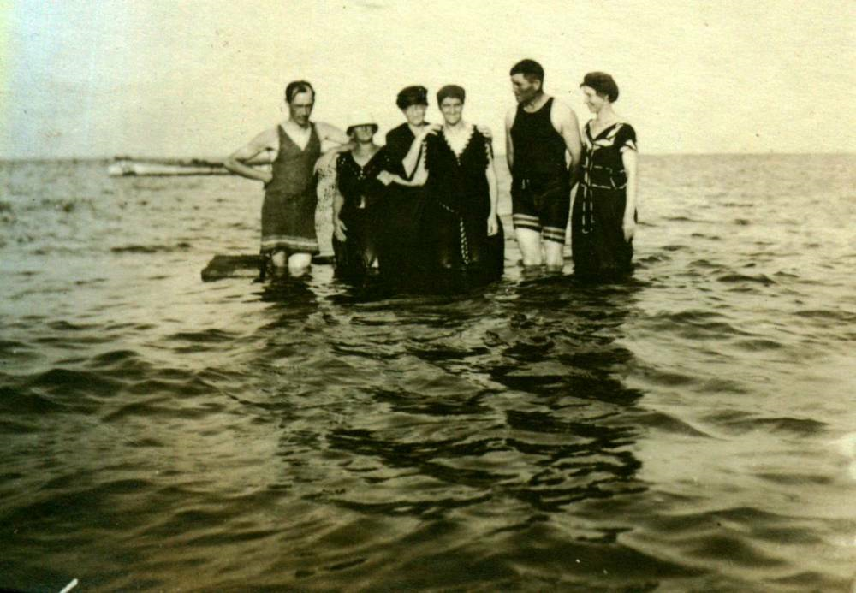
Church picnic at Bayside, including: Edgar Fowlie,

Edgar Fowlie,
Glendenning collection

